**IDEATION PHASE**

**DEFINE THE PROBLEM STATEMENTS**

|  |  |
| --- | --- |
| **DATE** | 29 September 2022 |
| **TEAM ID** | PNT2022TMID50562 |
| **PROJECT NAME** | Project – Personal Expense Tracker Application |
| **MAXIMUM MARKS** | 2 Marks |

**CUSTOMER PROBLEM STATEMENT:**

**PERSONAL EXPENSE TRACKER APPLICATION:**

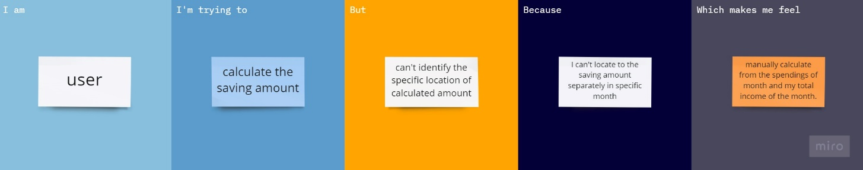

**Problem Statement:**

All the financial decisions and activities that you make are unable to keep a track of it. This application makes your life easier by helping you to manage your finances efficiently. A personal finance application will not only help you with budgeting and accounting but also give you helpful insights into financial management. In simple words, personal finance entails all the financial decisions and activities that a Finance app makes your life easier by helping you to manage your finances efficiently. A personal finance app will not only help you with budgeting and accounting but also give you helpful insights about money management.

Personal finance applications will ask users to add their expenses and based on their expense’s wallet balance will be updated which will be visible to the user. Also, users can get an analysis of their expenditures in graphical forms. They have an option to set a limit for the amount to be used for that particular month if the limit is exceeded the user will be notified with an email alert.

1. Whom does the problem affect?

The user does not know how to manage their daily expenses manually. Does not have enough knowledge in budget handling. To the person who does not have a limit on spending money. The group that is facing the problem is the users currently facing issues in saving money. Most people would not have made up their minds about how to save money.

2. What are the boundaries of the problem?

A person who is above 16, starts spending money for their needs because below 16 people do not need much money to be spent. Illiterates or people who are not educated much find it difficult to track their expenses. The boundaries will be based on the individual’s ratio and also the available applications that are available to choose from and continue for the next few years. The person should set some boundary values based on the income for each expenditure. This way the boundaries extend to effectively manage the expenses.

3. What is the issue?

The people who are struggling to find a better way to manage their expenses is the major issue and the problem that requires a better solution that should include the issues that are left out by the most available solutions in day-to-day life. The project should find the user’s ability to admit to the desired money management for the savings that they have earned.

The impact that the issue makes current days is that there is huge confusion about getting a good application that is available. The failure is unable to get a suitable expense tracker makes the users lose hope and unwillingly buy products in EMI rather than the ones they had wished to carry. This impact makes the lose their mental stability and puts them under a lot of pressure of being unable to find a better way to save money. This has been in a state of not being able to fully recover from the problem that is quite been there for more than a decade. There are solutions to overcome this issue but, every solution that has been developed towards this had a flaw in any one of the things that are present in their ideas.

This issue needs a complete fix that is by analysing the expenses to that of the income-expenditure that is been spent by the users. This way the issue gets slowly fixed and the users will not have any issues in setting their limits for spending the money daily or monthly or sometimes losing them based on the unwanted expenditure.

The issue will be continuing to persist even if the project has been implemented. But still, the users will be even more cautious in selecting the right Personal expense application. Users if the issue is not solved then they will be suffering to find the expense tracker as it was before. So, the issue needs to be maintained at the earliest so that the users can concentrate on their day-to-day expenses and savings instead of searching for other ways.

4. When does the issue occur?

An issue occurs in expense tracking when there is a lack of control over the day-to-day expenses. The absence of clearly defined spending limits is one of the biggest frustrations when overseeing a person's expense management process.

There are expenses you cannot avoid. If you use the 50/30/20 budget, these should account for 50% of your spending. Necessities often include the following:

* Healthcare: Health insurance; out-of-pocket medical costs.
* Life insurance
* Child care
* Student loan payment

5. Where is the issue occurring?

The issue occurs when the user does not keep track of their expenses and day-to-day expenditures. For instance, if the user does not have enough money in his/her account or wallet, but tends to buy products beyond the budget list (buying unnecessary products/materials/things unknowingly), he might end up in trouble and disappointed.

So, in this situation, this personal expense tracker application will help the users by s sending notifications on a timely basis.

Some of the necessities that cannot avoid:

* Housing: Mortgage or rent
* Transportation: Car payment, gas, maintenance, and auto insurance.
* Utilities: Electricity, water, cell phone bills.

6. Why is it important that we fix the problem?

When you track your spending, you know where your money goes and you can ensure that your money is used wisely. Tracking your expenditures also allows you to understand why you're in debt and how you got there. This will then help you design a befitting strategy of getting out of debt.

The main reason you should track your expenses is to identify and eliminate wasteful spending habits in your financial life. Moreover, consistently tracking your expenses will help you maintain control of your finances, and promote better financial habits like saving and investing.

When you start tracking expenses, you can separate your spending into three categories: needs, wants, and savings. Tracking your spending on a regular basis can give you an accurate picture of where your money is going – and where you should like it to go instead.